**Project Design Phase-II**

**Technology Stack (Architecture & Stack)**

|  |  |
| --- | --- |
| Date | 28 June 2025 |
| Team ID | LTVIP2025TMID50169 |
| Project Name | iRevolution A Data-driven Exploration of Apple's iPhone Impact in India using Tableau |
| Maximum Marks | 4 Marks |

**Technical Architecture:**

The Deliverable shall include the architectural diagram as below and the information as per the table1 & table 2

**Example: Order processing during pandemics for offline mode**

**Reference:** [**https://developer.ibm.com/patterns/ai-powered-backend-system-for-order-processing-during-pandemics/**](https://developer.ibm.com/patterns/ai-powered-backend-system-for-order-processing-during-pandemics/)



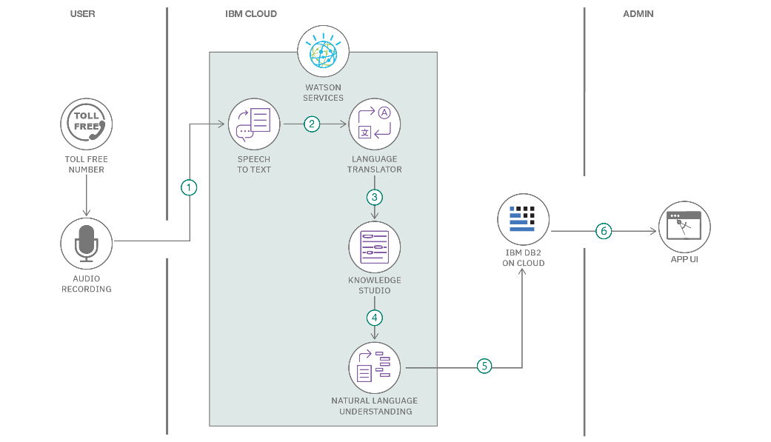

**Table-1 : Components & Technologies:**

**Table-2: Application Characteristics:**

| **S.No** | **Characteristics** | **Description** | **Technology** |
| --- | --- | --- | --- |
|  | Open-Source Frameworks | List the open-source frameworks used | Technology of Opensource framework |
|  | Security Implementations | List all the security / access controls implemented, use of firewalls etc. | e.g. SHA-256, Encryptions, IAM Controls, OWASP etc. |
|  | Scalable Architecture | Justify the scalability of architecture (3 – tier, Micro-services) | Technology used |
|  | Availability | Justify the availability of application (e.g. use of load balancers, distributed servers etc.) | Technology used |
|  | Performance | Design consideration for the performance of the application (number of requests per sec, use of Cache, use of CDN’s) etc. | Technology used |

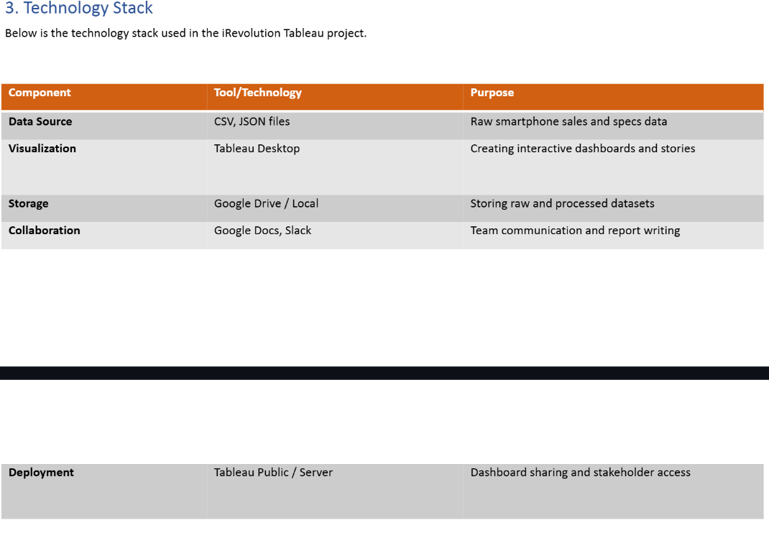

**References:**

[**https://c4model.com/**](https://c4model.com/)

[**https://developer.ibm.com/patterns/online-order-processing-system-during-pandemic/**](https://developer.ibm.com/patterns/online-order-processing-system-during-pandemic/)

[**https://www.ibm.com/cloud/architecture**](https://www.ibm.com/cloud/architecture)

[**https://aws.amazon.com/architecture**](https://aws.amazon.com/architecture)

[**https://medium.com/the-internal-startup/how-to-draw-useful-technical-architecture-diagrams-2d20c9fda90d**](https://medium.com/the-internal-startup/how-to-draw-useful-technical-architecture-diagrams-2d20c9fda90d)